Instruction:
Complete all questions in 2 hours.
- Von Neumann Simulator. This program simulates a very simple computer with the von Neumann architecture.
  - Download the von Neumann Simulator (VonNeumann.exe) program from google classroom in the Week-7 folder. Save it in your Documents folder and run it. You will see a window like this:
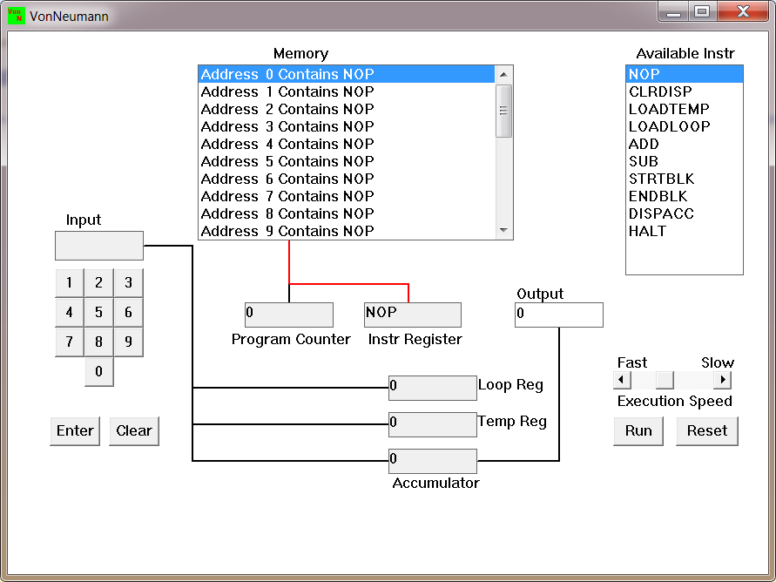

The simulator has a small program memory area which is available for programming. To enter your program instructions simply click on the “Available” instruction on the list on the right and then click on the “Memory” location you wish to put it in.

This simulator understands only the following ten instructions:
NOP | No Operation, i.e., do nothing.
LOADTEMP | Get a number from the keypad, completed by the Enter key, into the Temporary Register.
LOADLOOP | Get a number from the keypad, completed by the Enter key, into the Loop Register.
CLRDISP | Clear the Display.
ADD | Add the Temporary Register to the Accumulator
SUB | Subtract the Temporary Register from the Accumulator
DISPACC | Display the contents of the Accumulator
STRTBLK | Start of Loop Block
ENDBLK | End of Loop Block
HALT | Halt. Stop Program

  - Load the following program in the memory and explain what does the program does?
LOADTEMP
ADD
LOADTEMP
ADD
DISPAAC
HALT
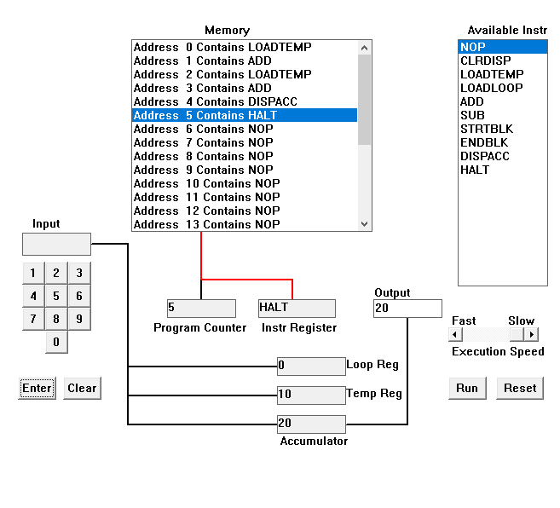
The program adds the two input numbers. Firstly, the LOADTEMP instruction loads the input data into temp register. The ADD command adds the data in accumulator and temp register and stores in the accumulator. Again, the next instruction LOADTEMP loads another input data into temp register and again the ADD adds the data in temp register to the data in accumulator and stores in accumulator. The next instruction DISPACC displays the accumulator data in the output and the program terminates with the next instruction HALT.

  - Write the program to add three numbers together and explain how does your code works?
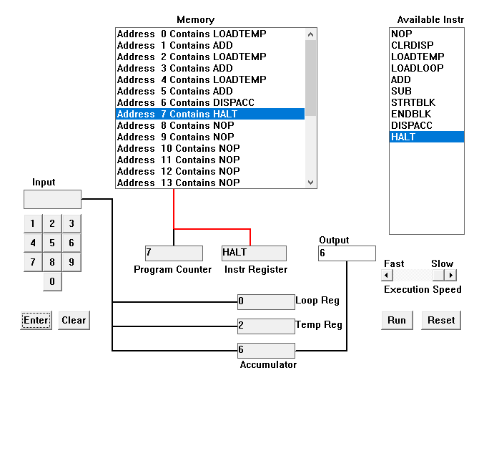
The program adds the three input numbers. Firstly, the LOADTEMP instruction loads the input data into temp register. The ADD command adds the data in accumulator and temp register and stores in the accumulator. Again, the next instruction LOADTEMP loads another input data into temp register and again the ADD adds the data in temp register to the data in accumulator and stores in accumulator. These set of instruction are repeated one more time which will also do the same as previous (adds the inputted data to the accumulator). The next instruction DISPACC displays the accumulator data in the output and the program terminates with the next instruction HALT.

  - Write the program to perform
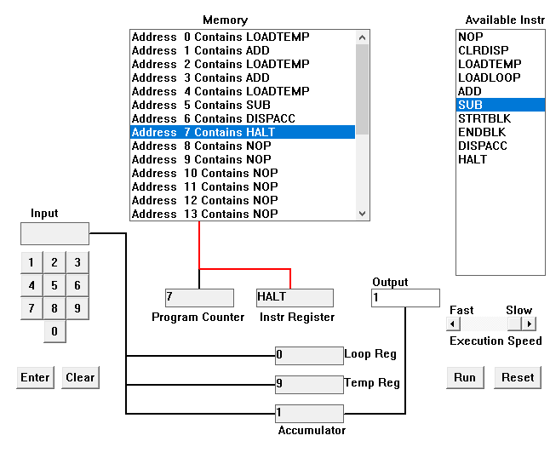
7+3-9

The program adds the first two input numbers and subtract the last number. Firstly, the LOADTEMP instruction loads the input data into temp register. The ADD command adds the data in accumulator and temp register and stores in the accumulator. Again, the next instruction LOADTEMP loads another input data into temp register and again the ADD adds the data in temp register to the data in accumulator and stores in accumulator. Similarly, the LOADTEMP loads input number again into temp register but now in next instruction the temp register data is subtracted from the accumulator by the SUB instruction. The next instruction DISPACC displays the accumulator data in the output and the program terminates with the next instruction HALT.
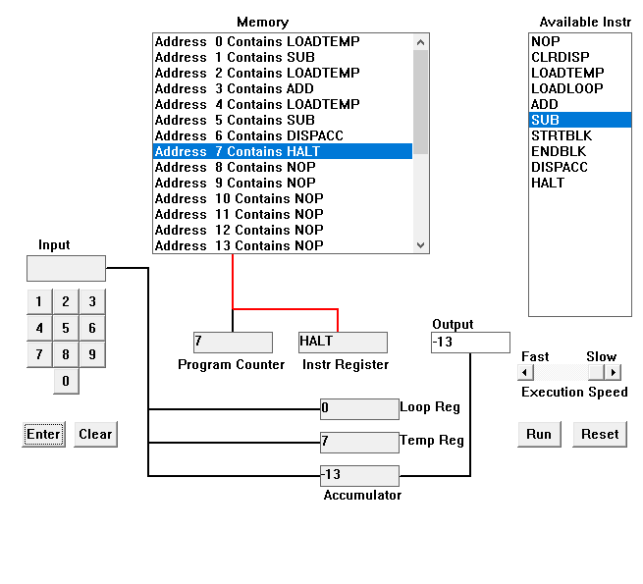
-9+3-7
Like the previous program, the LOADTEMP instruction loads the input data into temp register. The SUB command subtracts the temp register data from the data in accumulator and again stores in the accumulator. Again, the next instruction LOADTEMP loads another input data into temp register and again the ADD adds the data in temp register to the data in accumulator and stores in accumulator. Again, the first two instructions are the same which takes input and subtracts from the accumulator data. After all these computations, the next instruction DISPACC displays the accumulator data in the output and the program terminates with the next instruction HALT.

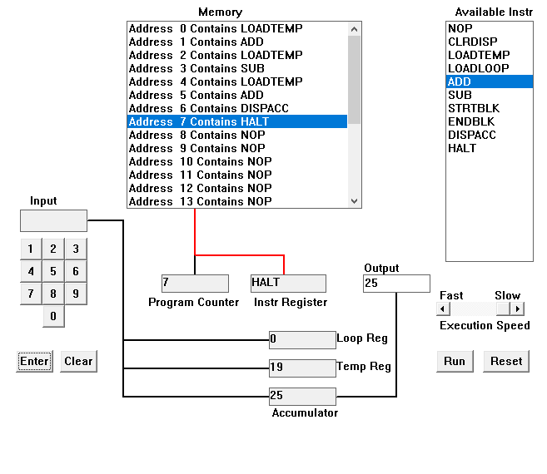
13-7+19

The first instruction LOADTEMP loads the input data into temp register. The ADD command adds the temp register data with the data in accumulator and again stores in the accumulator. The next number is subtracted from accumulator and the final number is again added to the accumulator. The next instruction DISPACC displays the accumulator data in the output and the program terminates with the next instruction HALT.

  - Write a program to perform
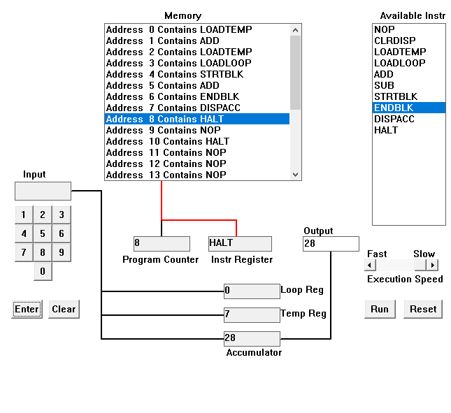
7+(7*3)

The program is described in steps below:
- Firstly, the input number (7) is loaded into temp register with LOADTEMP instruction.
- The number is added with the accumulator and stored in the accumulator.
- Another number (7) for multiplication is received into temp register with LOADTEMP.
- Then, a number (3) for controlling loop is received through input into the loop register with the LOADLOOP instruction.
- And, with the STRTBLK and ENDBLK defines loop body where the ADD instruction adds the temp register’s data and accumulator data and again replaces into the accumulator.
- After the loop register data reaches 0, the loop is terminated and DISPACC instruction displays the accumulator data in the output and the program is terminated with HALT instruction.
3+(3*7)
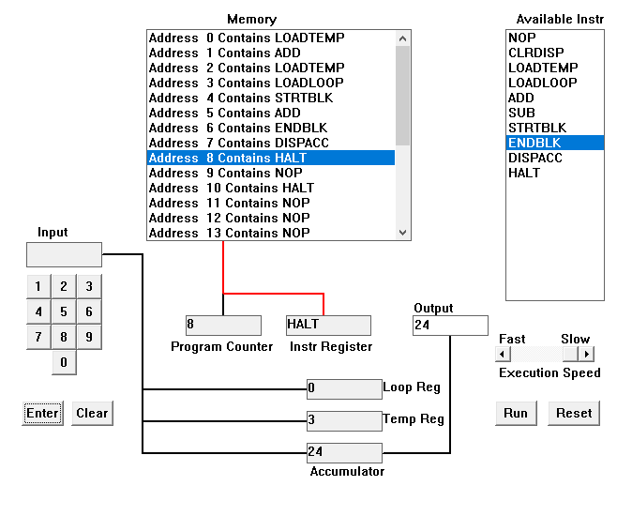

The program is described in steps below:
- Firstly, the input number (3) is loaded into temp register with LOADTEMP instruction.
- The number is added with the accumulator and stored in the accumulator.
- Another number (3) for multiplication is received into temp register with LOADTEMP.
- Then, a number (7) for controlling loop is received through input into the loop register with the LOADLOOP instruction.
- And, with the STRTBLK and ENDBLK defines loop body where the ADD instruction adds the temp register’s data and accumulator data and again replaces into the accumulator.
- After the loop register data reaches 0, the loop is terminated and DISPACC instruction displays the accumulator data in the output and the program is terminated with HALT instruction.

  - Write a program to add first 10 natural numbers.
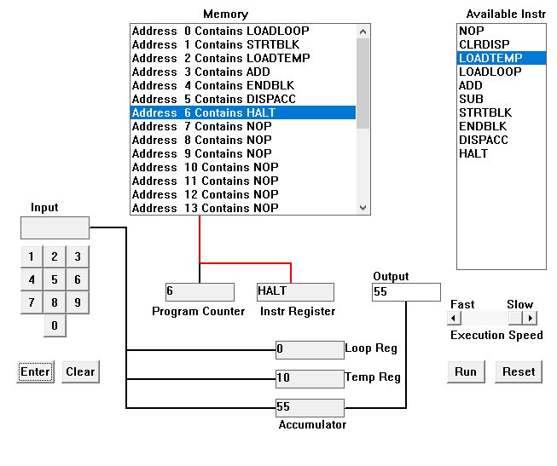
This program adds all the numbers entered through the input and displays the final sum in the output. The number of times the user input is taken is controlled by the first input which is received into the loop register by the command LOADLOOP command.
The program is described in steps below:
- Firstly, the input number (10) is loaded into loop register with LOADLOOP instruction.
- Now the instructions between STRTBLK and ENDBLK is repeated 10 times.
- In each iteration, the new number from user is taken and added with the accumulator.
- So, if in each iteration we provide the numbers from 1 to 10, it will eventually calculate the sum of first 10 natural numbers.
- After the loop register data reaches 0, the loop is terminated and DISPACC instruction displays the accumulator data in the output and the program is terminated with HALT instruction.

